| Cybersecurity |
| --- |
| Penetration Test Report |

Rekall Corporation

Penetration Test Report

# 

## Confidentiality Statement

This document contains confidential and privileged information from Rekall Inc. (henceforth known as Rekall). The information contained in this document is confidential and may constitute inside or non-public information under international, federal, or state laws. Unauthorized forwarding, printing, copying, distribution, or use of such information is strictly prohibited and may be unlawful. If you are not the intended recipient, be aware that any disclosure, copying, or distribution of this document or its parts is prohibited.

Table of Contents

Confidentiality Statement 2

Contact Information 4

Document History 4

Introduction 5

Assessment Objective 5

Penetration Testing Methodology 6

Reconnaissance 6

Identification of Vulnerabilities and Services 6

Vulnerability Exploitation 6

Reporting 6

Scope 7

Executive Summary of Findings 8

Grading Methodology 8

Summary of Strengths 9

Summary of Weaknesses 9

Executive Summary Narrative 10

Summary Vulnerability Overview 13

Vulnerability Findings 14

# 

## Contact Information

| **Company Name** | CyberStrike |
| --- | --- |
| **Contact Name** | Kevin Wang |
| **Contact Title** | Pentester |

## 

## Document History

| **Version** | **Date** | **Author(s)** | **Comments** |
| --- | --- | --- | --- |
| 001 | Oct. 24, 2022 | Kevin Wang |  |

# 

## Introduction

In accordance with Rekall policies, our organization conducts external and internal penetration tests of its networks and systems throughout the year. The purpose of this engagement was to assess the networks’ and systems’ security and identify potential security flaws by utilizing industry-accepted testing methodology and best practices.

For the testing, we focused on the following:

* Attempting to determine what system-level vulnerabilities could be discovered and exploited with no prior knowledge of the environment or notification to administrators.
* Attempting to exploit vulnerabilities found and access confidential information that may be stored on systems.
* Documenting and reporting on all findings.

All tests took into consideration the actual business processes implemented by the systems and their potential threats; therefore, the results of this assessment reflect a realistic picture of the actual exposure levels to online hackers. This document contains the results of that assessment.

### Assessment Objective

The primary goal of this assessment was to provide an analysis of security flaws present in Rekall’s web applications, networks, and systems. This assessment was conducted to identify exploitable vulnerabilities and provide actionable recommendations on how to remediate the vulnerabilities to provide a greater level of security for the environment.

We used our proven vulnerability testing methodology to assess all relevant web applications, networks, and systems in scope.

Rekall has outlined the following objectives:

Table 1: Defined Objectives

| **Objective** |
| --- |
| Find and exfiltrate any sensitive information within the domain. |
| Escalate privileges. |
| Compromise several machines. |

# 

## Penetration Testing Methodology

### Reconnaissance

### 

We begin assessments by checking for any passive (open source) data that may assist the assessors with their tasks. If internal, the assessment team will perform active recon using tools such as Nmap and Bloodhound.

### Identification of Vulnerabilities and Services

We use custom, private, and public tools such as Metasploit, hashcat, and Nmap to gain perspective of the network security from a hacker’s point of view. These methods provide Rekall with an understanding of the risks that threaten its information, and also the strengths and weaknesses of the current controls protecting those systems. The results were achieved by mapping the network architecture, identifying hosts and services, enumerating network and system-level vulnerabilities, attempting to discover unexpected hosts within the environment, and eliminating false positives that might have arisen from scanning.

### Vulnerability Exploitation

Our normal process is to both manually test each identified vulnerability and use automated tools to exploit these issues. Exploitation of a vulnerability is defined as any action we perform that gives us unauthorized access to the system or the sensitive data.

### Reporting

Once exploitation is completed and the assessors have completed their objectives, or have done everything possible within the allotted time, the assessment team writes the report, which is the final deliverable to the customer.

# 

## Scope

Prior to any assessment activities, Rekall and the assessment team will identify targeted systems with a defined range or list of network IP addresses. The assessment team will work directly with the Rekall POC to determine which network ranges are in-scope for the scheduled assessment.

It is Rekall’s responsibility to ensure that IP addresses identified as in-scope are actually controlled by Rekall and are hosted in Rekall-owned facilities (i.e., are not hosted by an external organization). In-scope and excluded IP addresses and ranges are listed below.

# 

# 

## Executive Summary of Findings

## 

### Grading Methodology

Each finding was classified according to its severity, reflecting the risk each such vulnerability may pose to the business processes implemented by the application, based on the following criteria:

**Critical**: Immediate threat to key business processes.

**High**: Indirect threat to key business processes/threat to secondary business processes.

**Medium**: Indirect or partial threat to business processes.

**Low**: No direct threat exists; vulnerability may be leveraged with other vulnerabilities.

Informational: No threat; however, it is data that may be used in a future attack.

As the following grid shows, each threat is assessed in terms of both its potential impact on the business and the likelihood of exploitation:

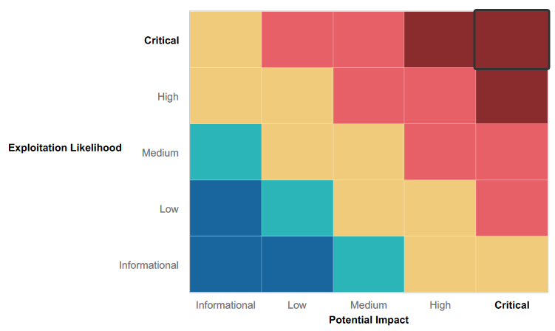

### 

### Summary of Strengths

While the assessment team was successful in finding several vulnerabilities, the team also recognized several strengths within Rekall’s environment. These positives highlight the effective countermeasures and defenses that successfully prevented, detected, or denied an attack technique or tactic from occurring.

* Some users had strong passwords that we’re unable to be cracked by John
* CS attempted a few exploits in Metasploit that were unsuccessful in attaining a meterpreter shell

### Summary of Weaknesses

We successfully found several critical vulnerabilities that should be immediately addressed in order to prevent an adversary from compromising the network. These findings are not specific to a software version but are more general and systemic vulnerabilities.

* Open ports
* Weak user passwords cracked by John tool or guessed
* Company information available on OSINT such as a user’s credentials
* Cross-site scripting (XSS) reflected
* Cross-site scripting (XSS) stored
* Sensitive data exposure
* Local file inclusion
* SQL injection
* Command injection
* PHP injection
* Brute force attack
* Session management
* Directory traversal
* Port 80, 21 open
* Weak passwords
* Lateral movement
* Privilege Escalation

## Executive Summary

Day 1

* CS performed cross-site scripting reflected to capture flag 1 by inputting an alert payload.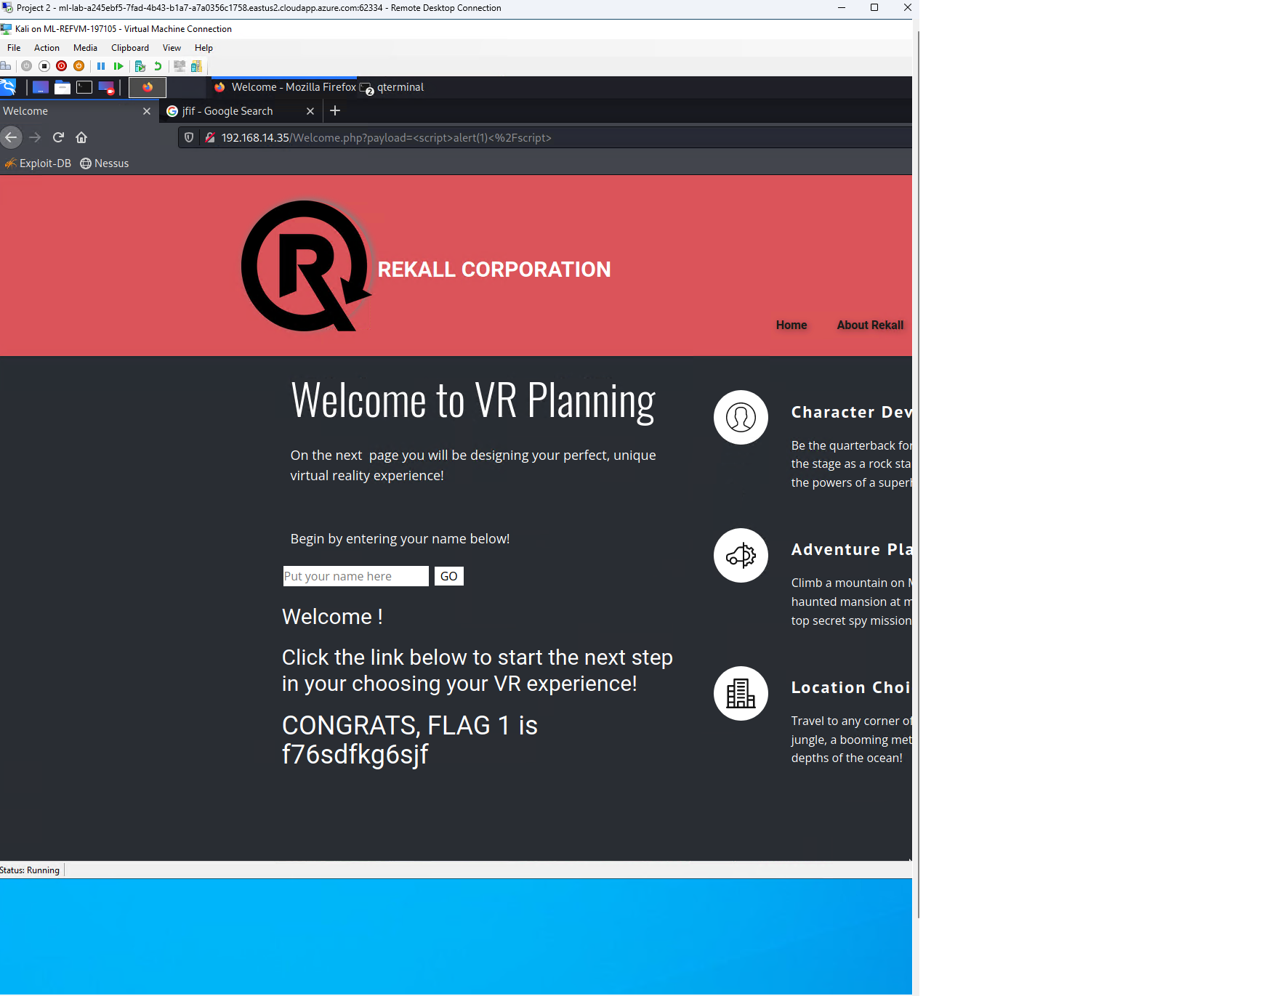
* CS performed cross-site scripting reflected again on the memory-planner.php directory but had to get past the input validation this time and had to split up the payload to bypass it.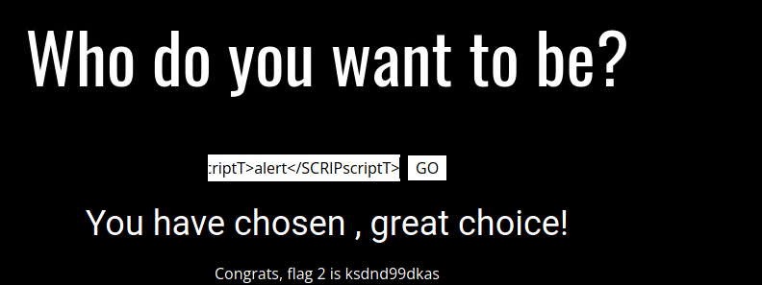
* CS also succeeded in cross-site scripting stored by inputting the same command from inputting the same payload as cross-site scripting reflected.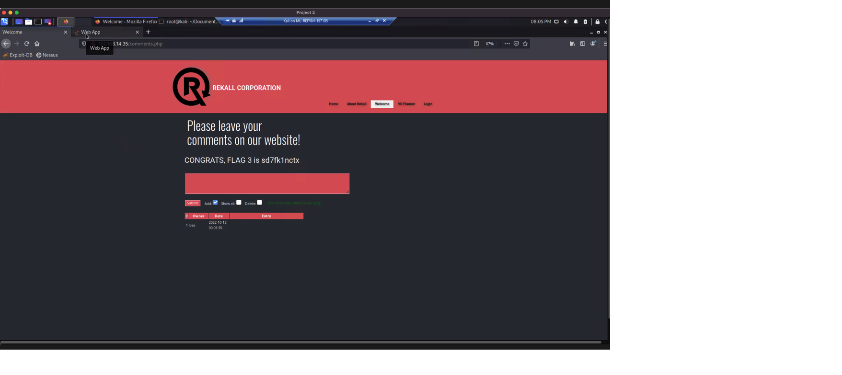
* CS used curl command to get the http response header of the About-Rekall.php directory and found the flag.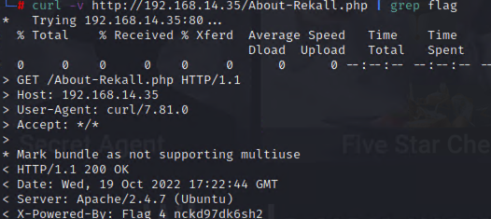
* CS used local file inclusion by uploading a php file to find flag 5. 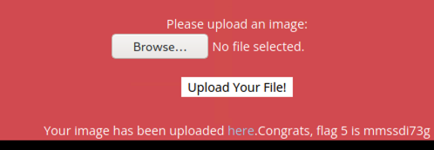
* CS used local file inclusion again to find flag 6 but had to add a jpg extension to the file to bypass the input validation.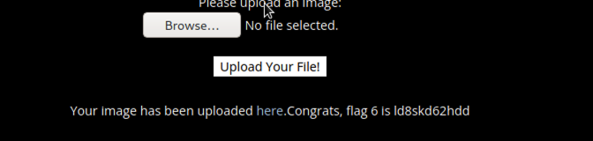
* CS successfully performed a SQL injection on the login.php “User Login” field.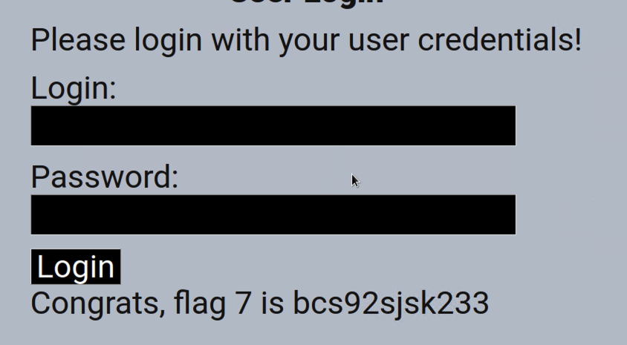
* CS then viewed the HTML page source of the login.php and found credentials for the “Admin Login’ which revealed flag 8.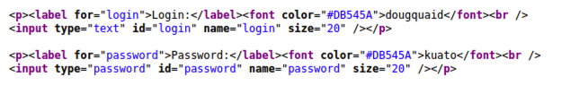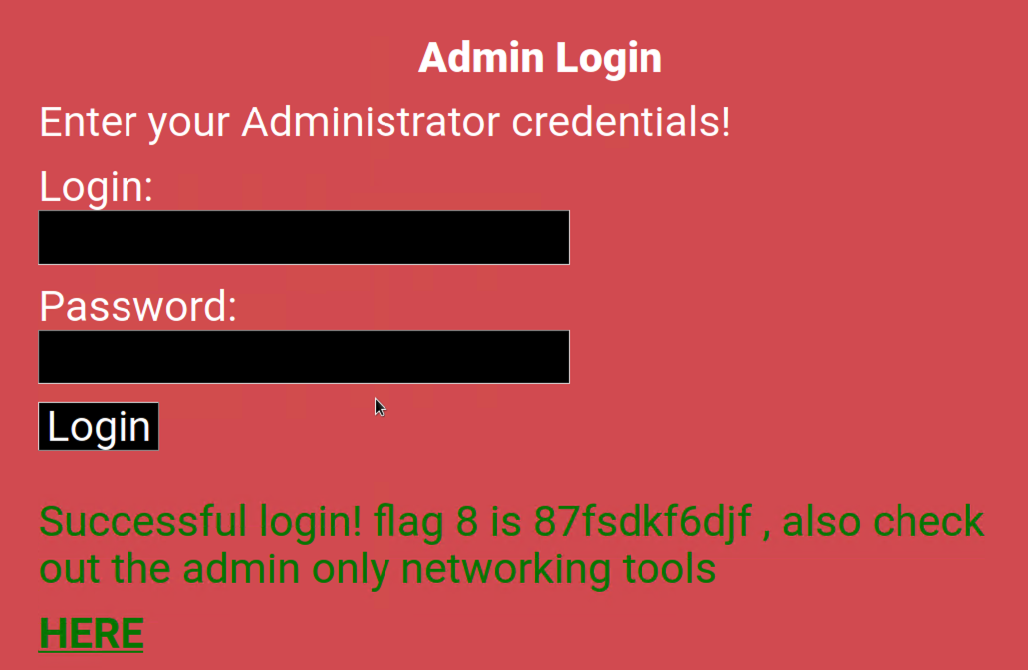
* CS also found sensitive data exposure, flag9 in the robots.txt directory.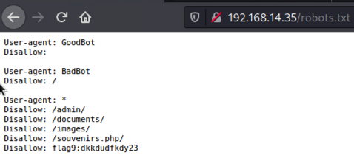
* CS successfully performed command injection on the networking.php directory by using the cat command in the “DNS Check” field to view the vendors.txt file.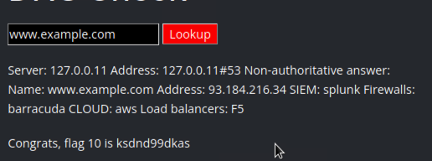
* CS successfully performed command injection on the “MX Record Checker” field by using the same command for flag 10, but had to bypass input validation that would strip both ‘&’ and ‘;’. CS bypassed the input validation by using ‘|’.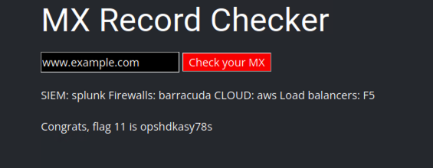
* CS found a user named ‘melina’ in the /etc/passwd file with the common injection vulnerability used for flag 10 and 11. CS guessed the password as melina’s password was weak.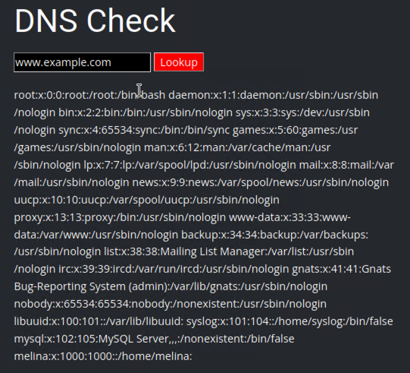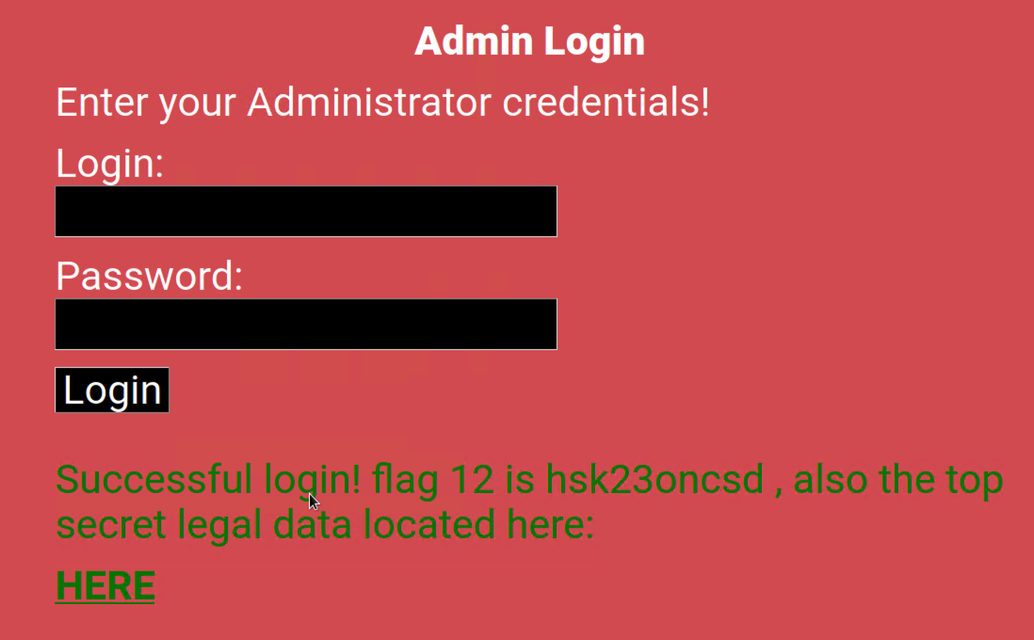
* CS used the hidden webpage found in the robots.txt directory, souvenirs.php. CS then changed the URL to input a PHP injection and cat the /etc/passwd file.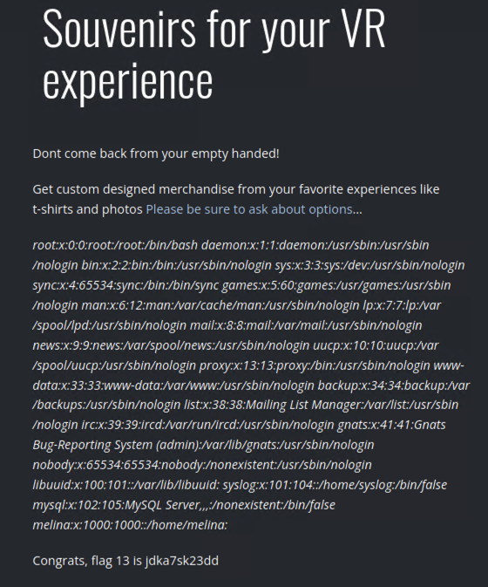
* CS attempted to test out different session IDs using Burp Suite’s Repeater tool for the “Restricted Area” web page and discovered a session management vulnerability. dd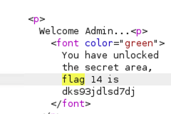
* CS used the previous command injection vulnerability to find the old_disclaimers directory and successfully performed directory traversal to capture flag 15.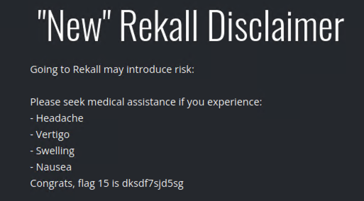

**Day 2**

* Used OSINT framework tools for reconnaissance and found Rekall’s domain information with who.is 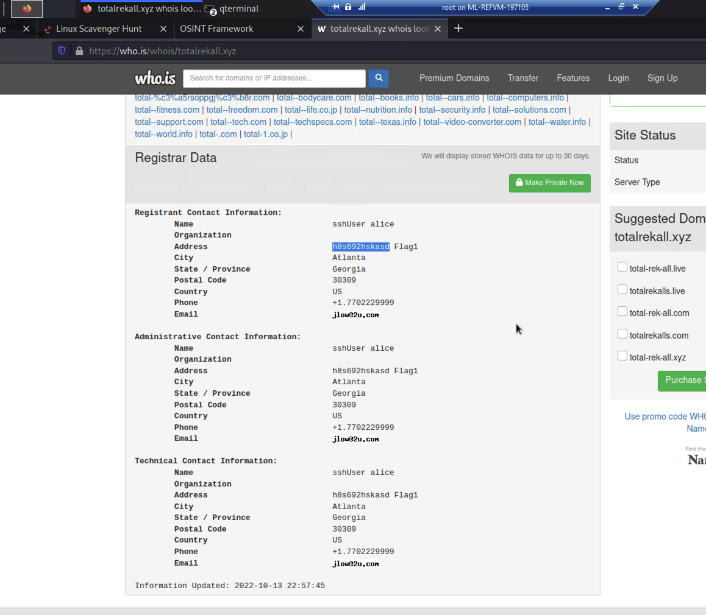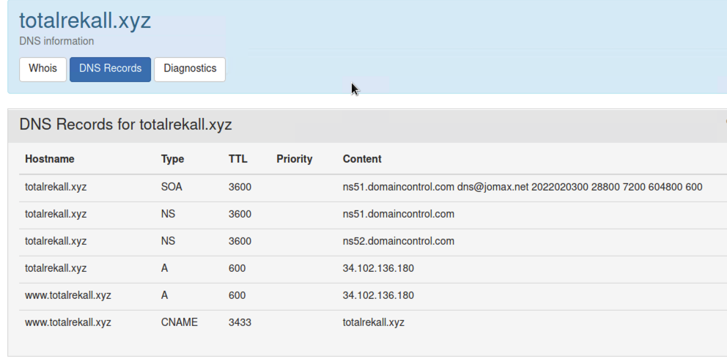
* Also used OSINT tool crt.sh to find certificate information on the domain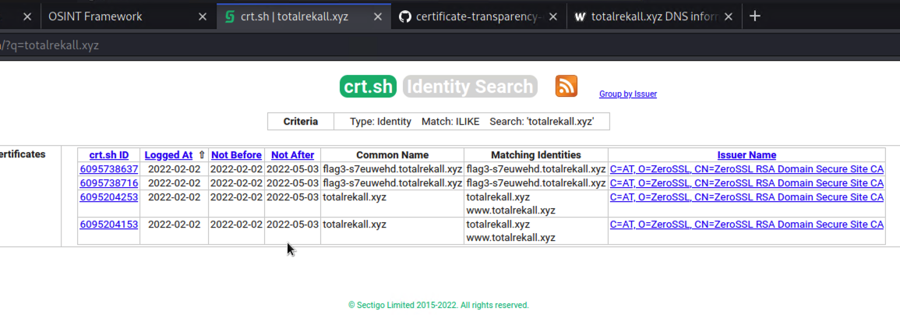
* CS proceeded to nmap the IP address of the domain in order to start scanning it and discovered 5 hosts up (not including the machine used to scan) 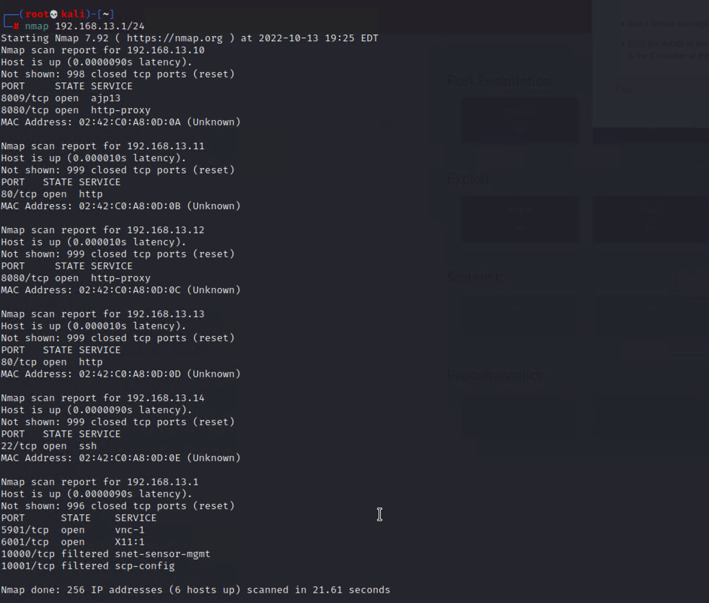
* CS also discovered whist host was running Drupal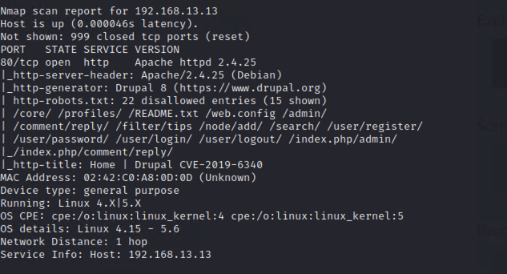
* CS also performed a Nessus scan on the host, 192.168.13.12 and found a critical vulnerability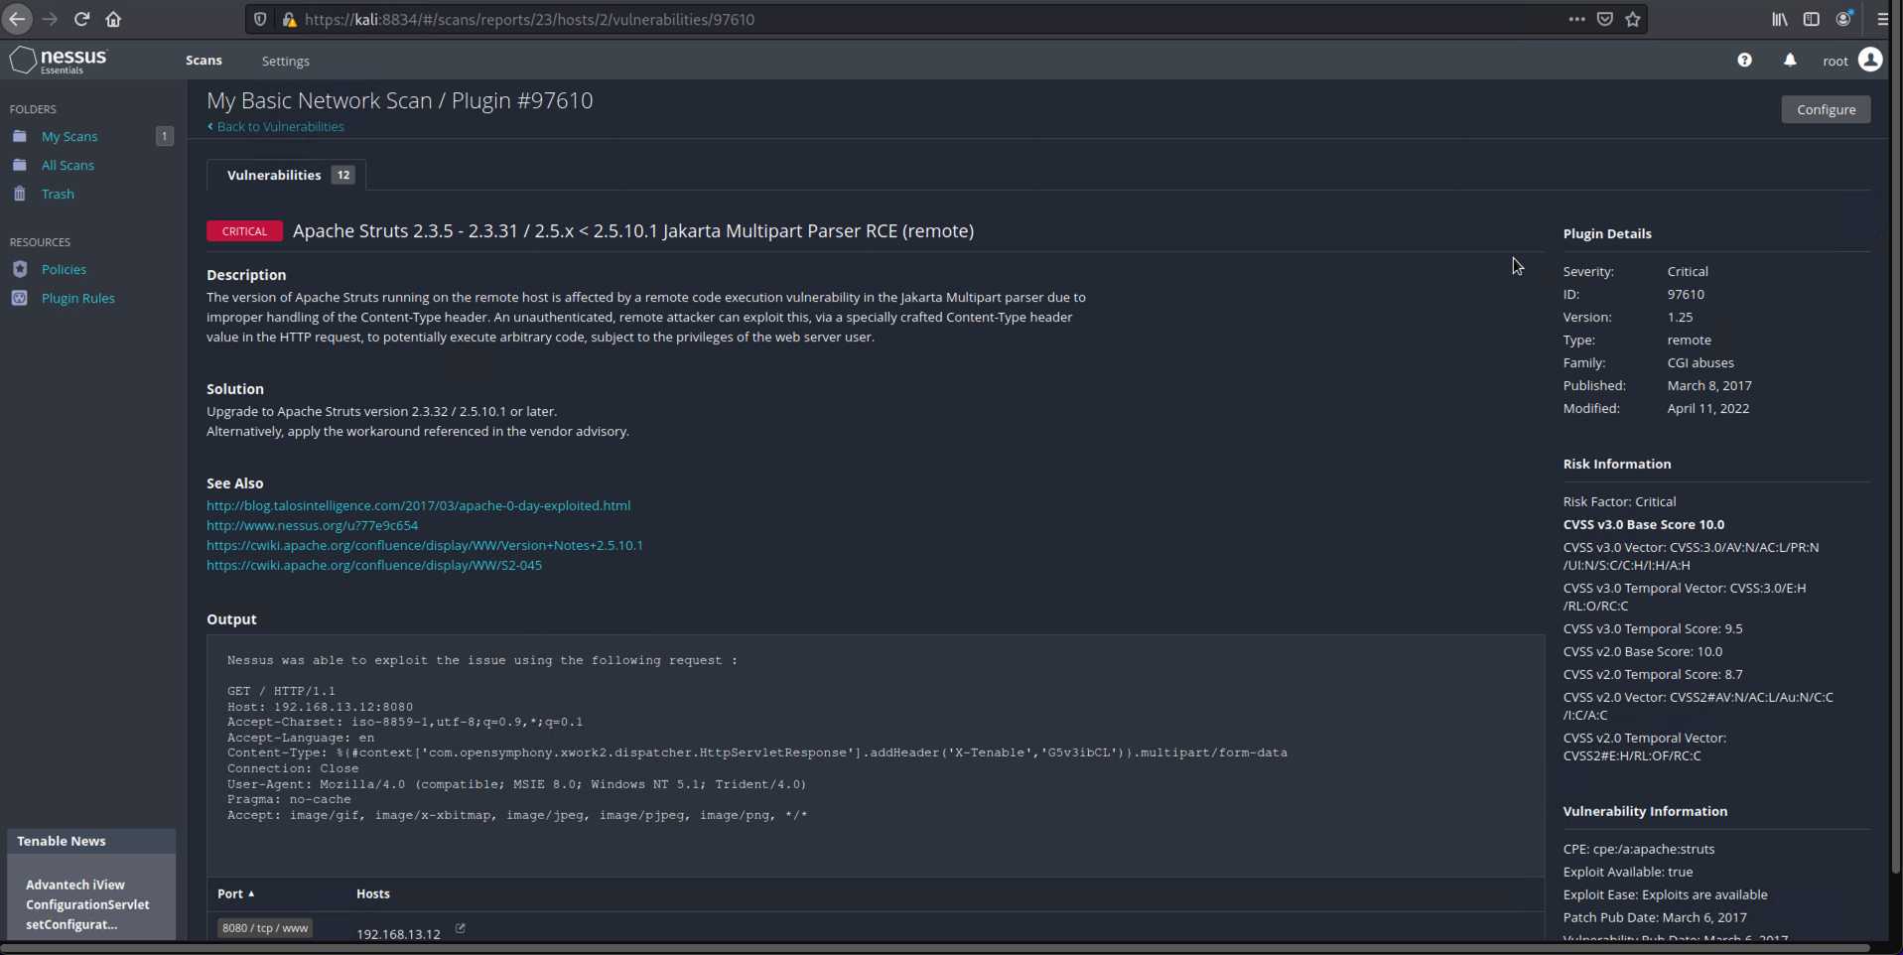
* CS proceeded to attempt exploits on Rekall’s hosts with Metasploit and successfully reached root shell with the tomcat_jsp_upload_bypass module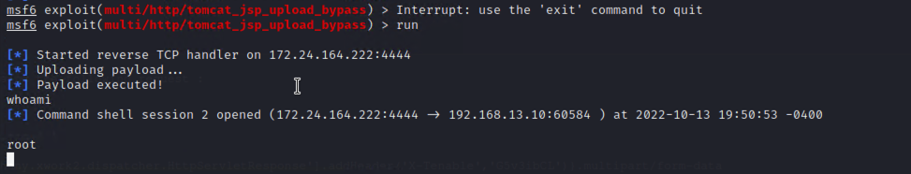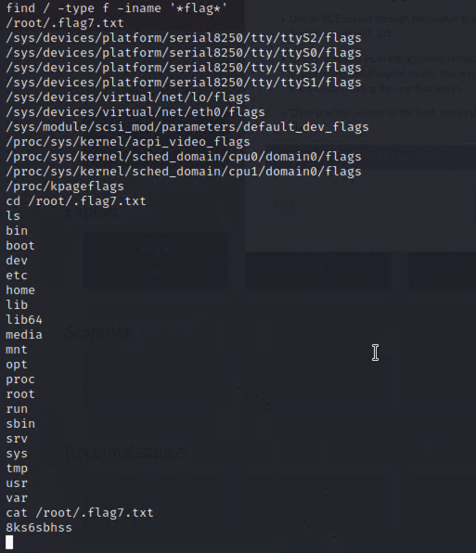
* CS attempted a few exploits, but were unable to create a session.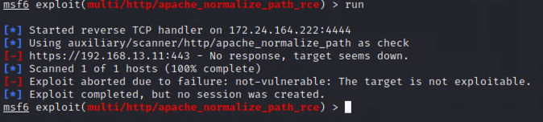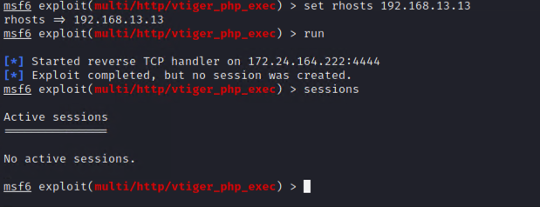
* However, CS did successfully exploit the target using apache_mod_cgi_bash_env_exec and struts2__content_type_ognl.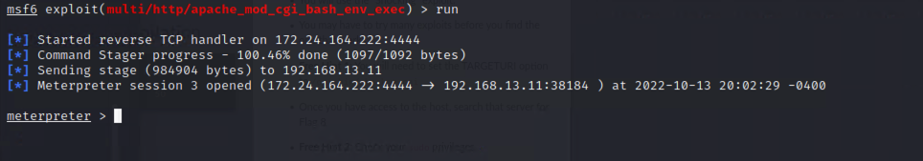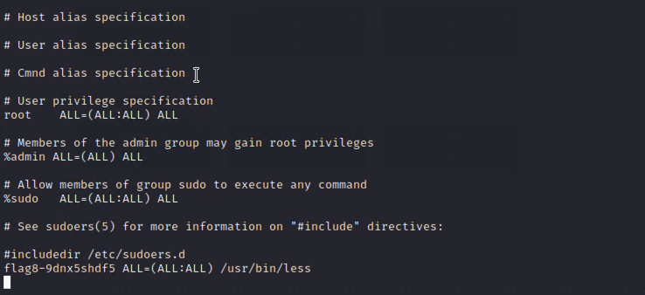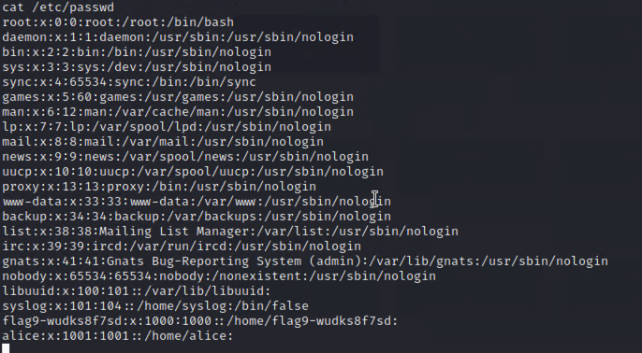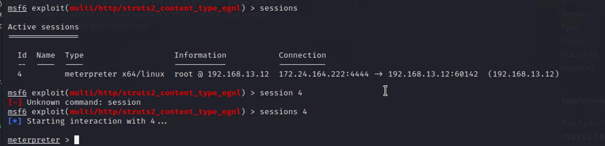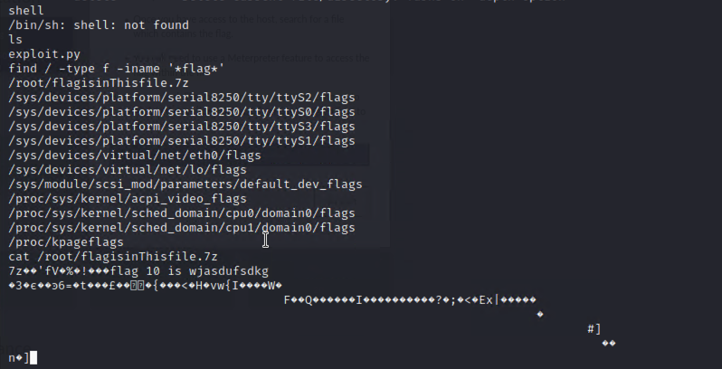
* CS attempted an exploit on host 192.168.13.13 but was unable to create a session with drupal_drupalgeddon. However, CS did succeed in creating a session on the host with drupal_restws_unserialize.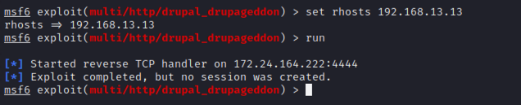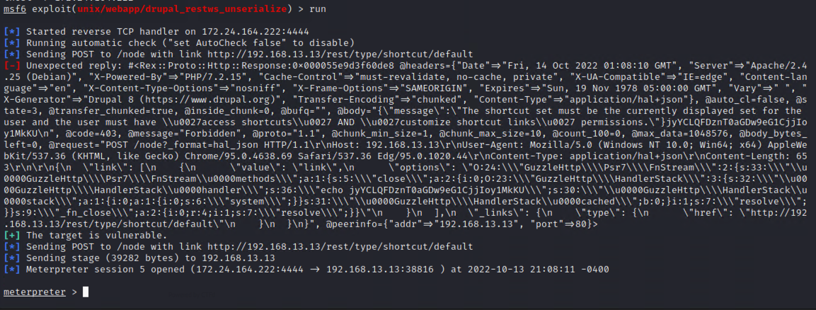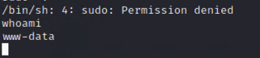
* CS successfully SSH into the host-alice by guessing the password and then getting root access by exploiting CVE-2019-14287
* 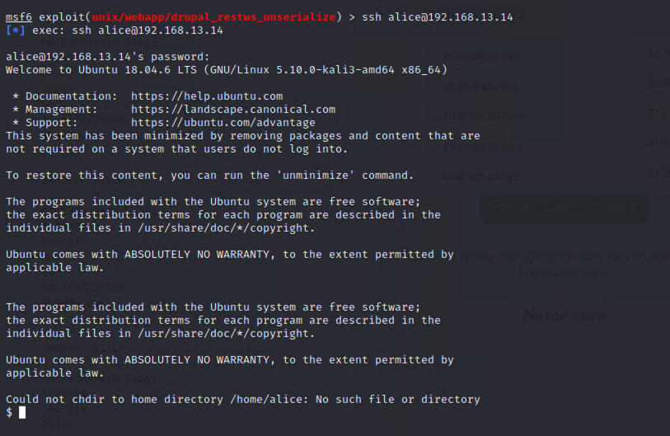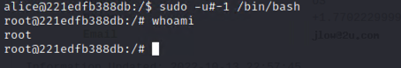

**Day 3**

* Used OSINT tools to find credentials of a user at Total Rekall then used John to crack the hash. 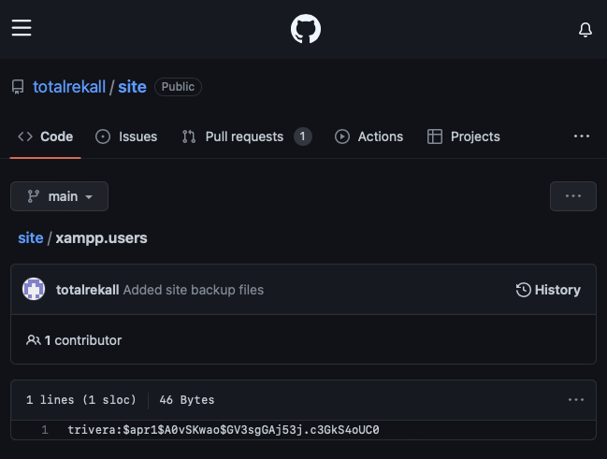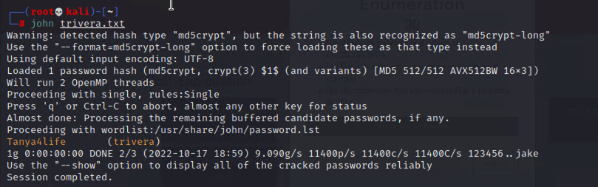
* Used Nmap to aggressively scan the subnet of hosts on 172.22.117.0/24 which allowed CS to find open ports and see if they were exploitable, which they were. On 172.22.117.20, port 80 was open so CS attempted to access the web page with the credentials obtained previously and succeeded.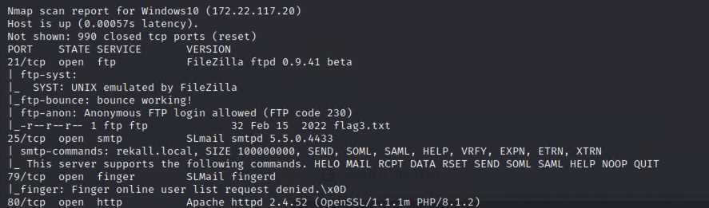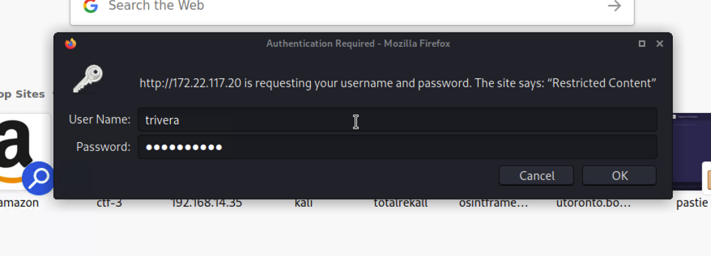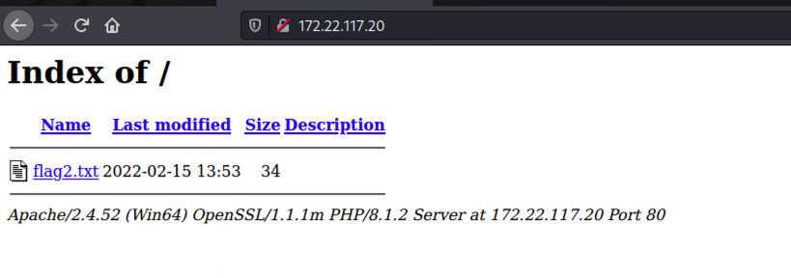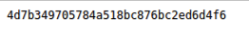
* CS also accessed 172.22.117.20 via ftp as port 21 was open.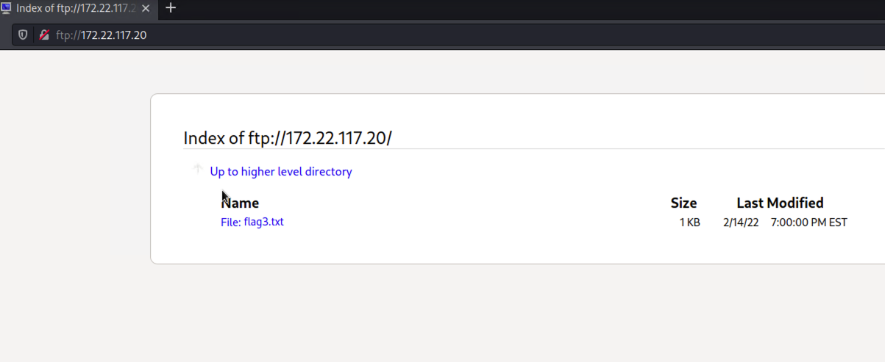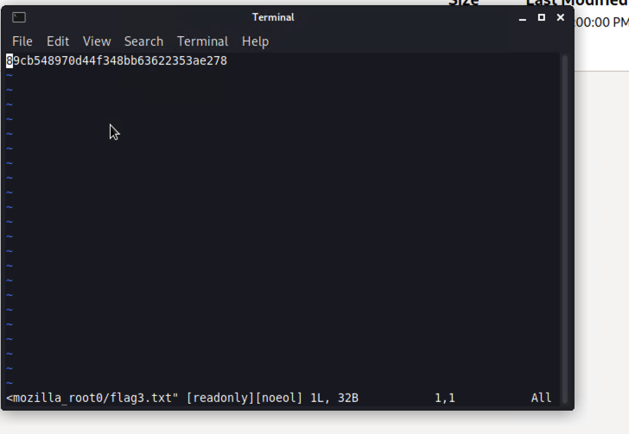
* CS further tried to exploit one of the vulnerabilities found in the nmap scan, SLmail. CS succeeded and accessed a session into the target machine.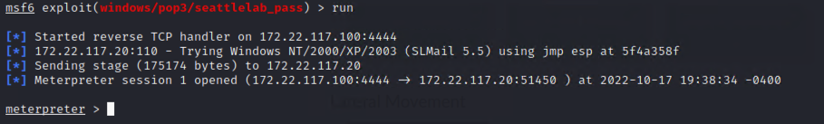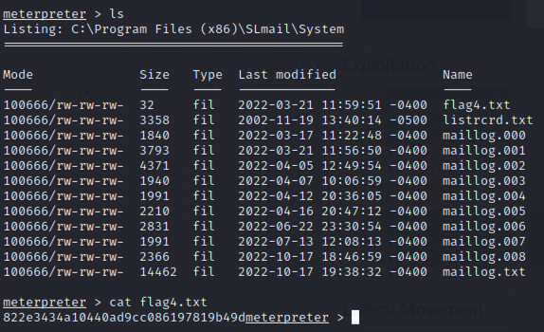
* CS accessed shell within the target machine and evaluated the scheduled tasks.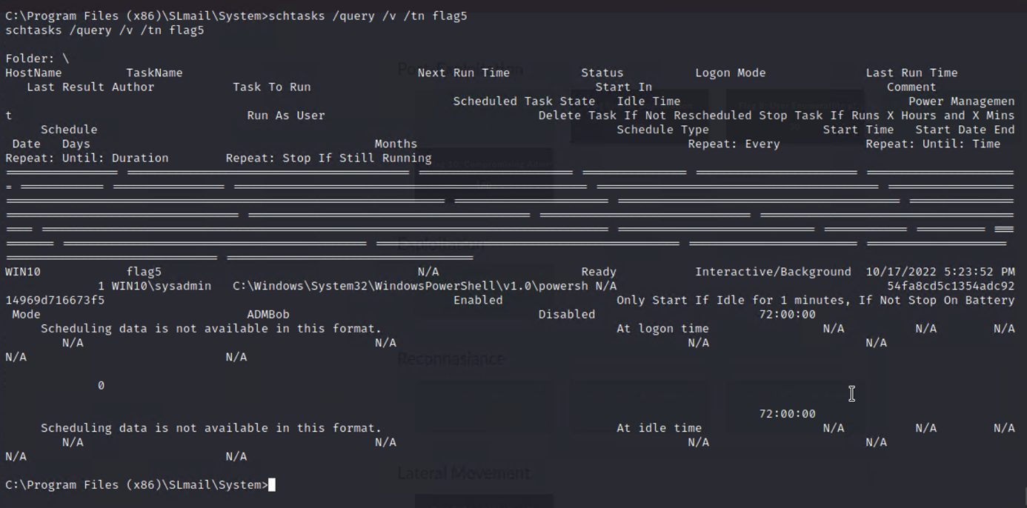
* CS also enumerated all the users on the machine.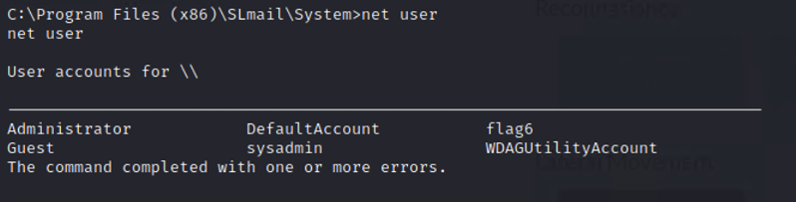
* CS then discovered all the password hashes of these users with the module, hashdump and used John to crack the hashes, but we’re unable to crack three of them.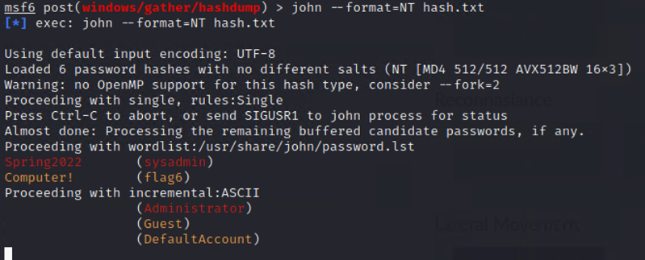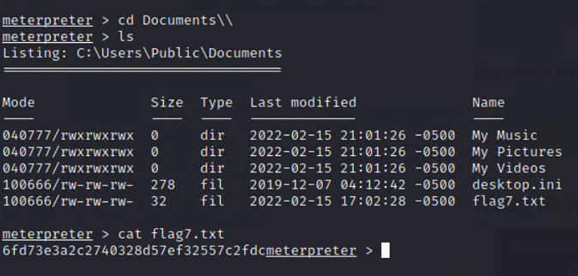
* CS used responder to listen for LLMNR broadcasts and captured the credentials of ADMBob then used John to crack the password hash.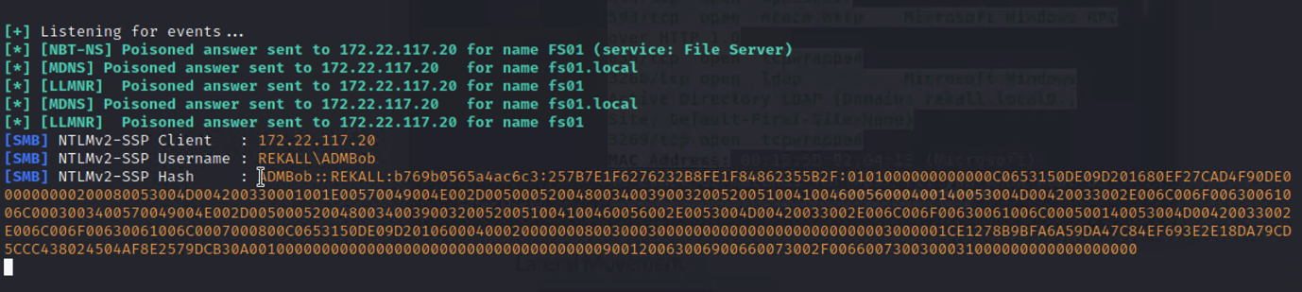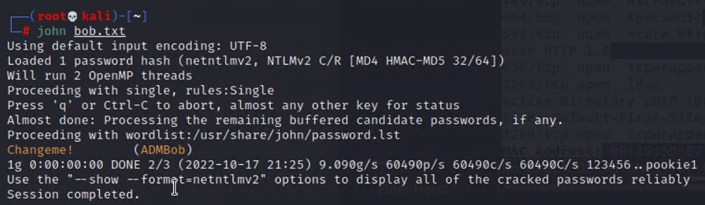
* With the credentials of ADMBob, CS moved laterally to access the WINDC01 machine with the wmi module.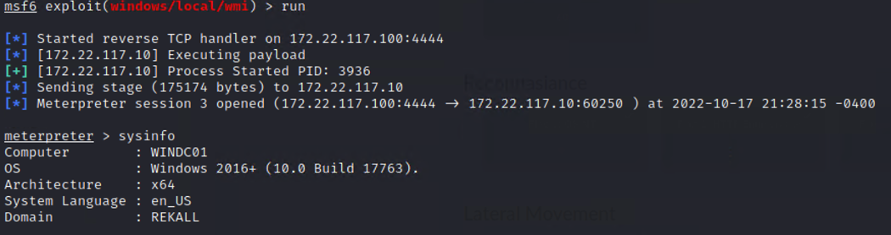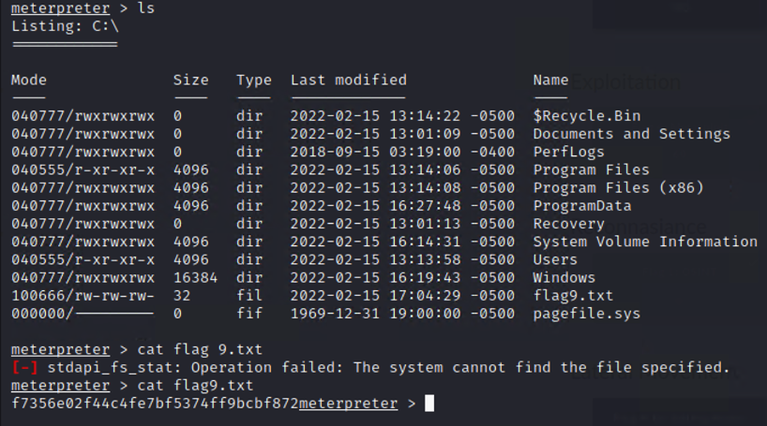
* CS discovered all of the users on the WINDC01 machine and then loaded kiwi to use dcsync_ntlm to find the password hash of the Administrator.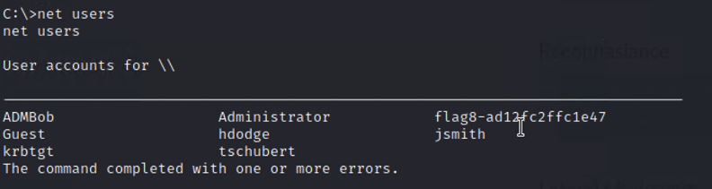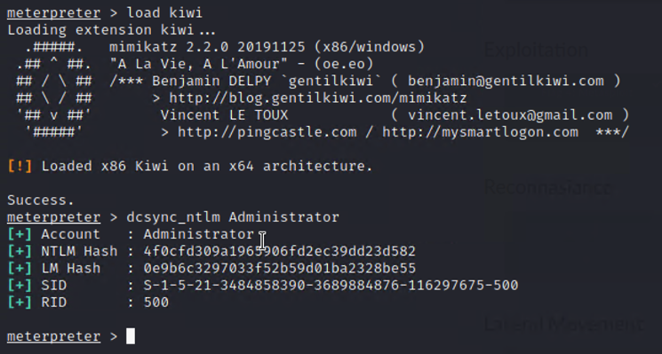

## Summary Vulnerability Overview

| **Vulnerability** | **Severity** |
| --- | --- |
| XSS Reflected | **Critical** |
| XSS Stored | **Critical** |
| Sensitive Data Exposure | **High** |
| Local File Inclusion | **High** |
| SQL Injection | **Critical** |
| Command Injection | **Critical** |
| Brute Force Attack | **High** |
| PHP Injection | **High** |
| Session Management | **High** |
| Directory Traversal | **High** |
| LLMNR Broadcasts | **Medium** |
| tomcat_jsp_upload_bypass | **Critical** |
| apache_mod_cgi_bash_env_exec | **Critical** |
| struts2__content_type_ognl | **Critical** |
| drupal_restws_unserialize | **Critical** |
| SSH | **Critical** |
| CVE-2019-14287 | **Critical** |
| OSINT Credentials | **High** |
| Port 80 | **Critical** |
| Port 21 | **Critical** |
| Hashdump and weak passwords | **High** |
| wmi | **Critical** |

The following summary tables represent an overview of the assessment findings for this penetration test:

| **Scan Type** | **Total** |
| --- | --- |
| Hosts | 8 |
| Ports | 28 |

| **Exploitation Risk** | **Total** |
| --- | --- |
| **Critical** | 13 |
| **High** | 8 |
| **Medium** | 1 |
| **Low** | 0 |

## Vulnerability Findings

| **Vulnerability 1** | **Findings** |
| --- | --- |
| **Title** | XSS Reflected |
| **Type (Web app / Linux OS / WIndows OS)** | Web app |
| **Risk Rating** | Critical |
| **Description** | The welcome.php directory of the web page allows users to enter payloads into the field. |
| **Images** |  |
| **Affected Hosts** | 192.168.14.35 |
| **Remediation** | Implement input validation and remove ability to input special characters such as ‘>’, ‘/’, etc. |

| **Vulnerability 2** | **Findings** |
| --- | --- |
| **Title** | XSS Stored |
| **Type (Web app / Linux OS / WIndows OS)** | Web app |
| **Risk Rating** | Critical |
| **Description** | The comments.php directory allows users to input payloads into the stored. |
| **Image** |  |
| **Affected Hosts** | 192.168.14.35 |
| **Remediation** | Implement input validation and remove ability to input special characters such as ‘>’, ‘/’, etc. |

| **Vulnerability 3** | **Findings** |
| --- | --- |
| **Title** | Sensitive Data Exposure |
| **Type (Web app / Linux OS / WIndows OS)** | Web app |
| **Risk Rating** | High |
| **Description** | The credentials for an admin account on the login.php directory was found in the HTML page source. |
| **Images** |  |
| **Affected Hosts** | 192.168.14.35 |
| **Remediation** | Remove sensitive data that can be accessed in the html page source. |

| **Vulnerability 4** | **Findings** |
| --- | --- |
| **Title** | Local File Inclusion |
| **Type (Web app / Linux OS / WIndows OS)** | Web app |
| **Risk Rating** | High |
| **Description** | Ability to upload a PHP file |
| **Images** |  |
| **Affected Hosts** | 192.168.14.35 |
| **Remediation** | Do not allow direct file path modification. |

| **Vulnerability 5** | **Findings** |
| --- | --- |
| **Title** | SQL Injection |
| **Type (Web app / Linux OS / WIndows OS)** | Web app |
| **Risk Rating** | Critical |
| **Description** | The user login for the login.php directory allows for SQL injection. |
| **Images** |  |
| **Affected Hosts** | 192.168.14.35 |
| **Remediation** | Implement input validation and remove ability to input special characters such as “ ‘ “, “/”, etc. |

| **Vulnerability 6** | **Findings** |
| --- | --- |
| **Title** | Command Injection |
| **Type (Web app / Linux OS / WIndows OS)** | Web app |
| **Risk Rating** | Critical |
| **Description** | The networking.php directory allows for users to input command injections. |
| **Images** |  |
| **Affected Hosts** | 192.168.14.35 |
| **Remediation** | Implement input validation and remove ability to input special characters such as “ | “, “&”, etc. |

| **Vulnerability 7** | **Findings** |
| --- | --- |
| **Title** | Brute Force Attack |
| **Type (Web app / Linux OS / WIndows OS)** | Web app |
| **Risk Rating** | High |
| **Description** | User melina had a simple password that was able to be guessed. Same password as username. |
| **Images** |  |
| **Affected Hosts** | 192.168.14.35 |
| **Remediation** | Use strong passwords consisting of upper and lowercase letters, numbers, and special characters. |

| **Vulnerability 8** | **Findings** |
| --- | --- |
| **Title** | PHP Injection |
| **Type (Web app / Linux OS / WIndows OS)** | Web app |
| **Risk Rating** | High |
| **Description** | CS was able to change the URL for the hidden directory found in robots.txt and input a PHP injection to display the /etc/passwd file. |
| **Images** |  |
| **Affected Hosts** | 192.168.14.35 |
| **Remediation** | Create a list of whitelisted commands and arguments. |

| **Vulnerability 9** | **Findings** |
| --- | --- |
| **Title** | Session Management |
| **Type (Web app / Linux OS / WIndows OS)** | Web app |
| **Risk Rating** | High |
| **Description** | CS used Burp Suite to test out different session IDs in the admin_legal_data.php directory. |
| **Images** |  |
| **Affected Hosts** | 192.168.14.35 |
| **Remediation** | Encrypt the session ID with MD5 hash. |

| **Vulnerability 10** | **Findings** |
| --- | --- |
| **Title** | Directory Traversal |
| **Type (Web app / Linux OS / WIndows OS)** | Web app |
| **Risk Rating** | High |
| **Description** | CS used directory traversal to access the disclaimer.php directory and find the disclaimer_1.txt file. |
| **Images** |  |
| **Affected Hosts** | 192.168.14.35 |
| **Remediation** | Implement input validation and remove ability to input special characters such as “ ‘ “, “/”, etc. and commands/arguments that can be used to exploit the web page. |

| **Vulnerability 11** | **Findings** |
| --- | --- |
| **Title** | Directory Traversal |
| **Type (Web app / Linux OS / WIndows OS)** | Web app |
| **Risk Rating** | High |
| **Description** | CS used directory traversal to access the disclaimer.php directory and find the disclaimer_1.txt file. |
| **Images** |  |
| **Affected Hosts** | 192.168.14.35 |
| **Remediation** | Implement input validation and remove ability to input special characters such as “ ‘ “, “/”, etc. and commands/arguments that can be used to exploit the web page. |

| **Vulnerability 12** | **Findings** |
| --- | --- |
| **Title** | tomcat_jsp_upload_bypass |
| **Type (Web app / Linux OS / WIndows OS)** | Linux OS |
| **Risk Rating** | Critical |
| **Description** | CS used metasploit and the tomcat_jsp_upload_bypass module to attain a meterpreter shell. |
| **Images** |  |
| **Affected Hosts** | 192.168.13.10 |
| **Remediation** | Patch system and ensure systems are up to date. |

| **Vulnerability 13** | **Findings** |
| --- | --- |
| **Title** | apache_mod_cgi_bash_env_exec |
| **Type (Web app / Linux OS / WIndows OS)** | Linux OS |
| **Risk Rating** | Critical |
| **Description** | CS used metasploit and the apache_mod_cgi_bash_env_exec module to attain a meterpreter shell. |
| **Images** |  |
| **Affected Hosts** | 192.168.13.11 |
| **Remediation** | Patch system and ensure systems are up to date. |

| **Vulnerability 14** | **Findings** |
| --- | --- |
| **Title** | struts2__content_type_ognl |
| **Type (Web app / Linux OS / WIndows OS)** | Linux OS |
| **Risk Rating** | Critical |
| **Description** | CS used metasploit and the struts2__content_type_ognl module to attain a meterpreter shell. |
| **Images** |  |
| **Affected Hosts** | 192.168.13.12 |
| **Remediation** | Patch system and ensure systems are up to date. |

| **Vulnerability 15** | **Findings** |
| --- | --- |
| **Title** | drupal_restws_unserialize |
| **Type (Web app / Linux OS / WIndows OS)** | Linux OS |
| **Risk Rating** | Critical |
| **Description** | CS used metasploit and the drupal_restws_unserialize module to attain a meterpreter shell. |
| **Images** |  |
| **Affected Hosts** | 192.168.13.13 |
| **Remediation** | Patch system and ensure systems are up to date. |

| **Vulnerability 16** | **Findings** |
| --- | --- |
| **Title** | SSH |
| **Type (Web app / Linux OS / WIndows OS)** | Linux OS |
| **Risk Rating** | Critical |
| **Description** | CS used SSH to remotely access alice@192.168.13.14 |
| **Images** |  |
| **Affected Hosts** | 192.168.13.14 |
| **Remediation** | Comment out port 22 in the sshd_config file as it is the default SSH port and use another port. Also change the setting for PermitRootLogin from yes to no. |

| **Vulnerability 17** | **Findings** |
| --- | --- |
| **Title** | CVE-2019-14287 |
| **Type (Web app / Linux OS / WIndows OS)** | Linux OS |
| **Risk Rating** | Critical |
| **Description** | CS used CVE-2019-14287 to attain root access from alice@192.168.13.14. |
| **Images** |  |
| **Affected Hosts** | 192.168.13.14 |
| **Remediation** | Patch system and ensure systems are up to date. |

| **Vulnerability 18** | **Findings** |
| --- | --- |
| **Title** | OSINT Credentials |
| **Type (Web app / Linux OS / WIndows OS)** | Web app |
| **Risk Rating** | Medium |
| **Description** | CS used OSINT to discover a user’s credentials from Total Rekall. |
| **Images** |  |
| **Affected Hosts** | 172.22.117.20 |
| **Remediation** | Ensure users do not share credentials and are not openly available on the web. |

| **Vulnerability 19** | **Findings** |
| --- | --- |
| **Title** | Port 80 |
| **Type (Web app / Linux OS / WIndows OS)** | Web app |
| **Risk Rating** | Critical |
| **Description** | CS used previously attained credentials to access Restricted Content at <http://172.22.117.20> by using John to crack the hash. |
| **Images** |  |
| **Affected Hosts** | 172.22.117.20 |
| **Remediation** | Ensure user passwords are strong by requiring a combination of uppercase and lowercase letters, numbers, and special characters. |

| **Vulnerability 20** | **Findings** |
| --- | --- |
| **Title** | Port 21 |
| **Type (Web app / Linux OS / WIndows OS)** | Web app |
| **Risk Rating** | Critical |
| **Description** | CS was able to access ftp://172.22.117.20 via open port 21. |
| **Images** |  |
| **Affected Hosts** | 172.22.117.20 |
| **Remediation** | Ensure user passwords are strong by requiring a combination of uppercase and lowercase letters, numbers, and special characters. |

| **Vulnerability 21** | **Findings** |
| --- | --- |
| **Title** | seattlelab_pass |
| **Type (Web app / Linux OS / WIndows OS)** | Windows OS |
| **Risk Rating** | Critical |
| **Description** | CS was able to access a meterpreter shell by using the seattlelab_pass module in Metasploit. |
| **Images** |  |
| **Affected Hosts** | 172.22.117.20 |
| **Remediation** | Ensure user passwords are strong by requiring a combination of uppercase and lowercase letters, numbers, and special characters. |

| **Vulnerability 22** | **Findings** |
| --- | --- |
| **Title** | Hashdump and Weak Passwords |
| **Type (Web app / Linux OS / WIndows OS)** | Windows OS |
| **Risk Rating** | High |
| **Description** | CS was able to use the hashdump module in Metasploit to get the hashes of users on the target machine and then used John to discover weak passwords. |
| **Images** |  |
| **Affected Hosts** | 172.22.117.20 |
| **Remediation** | Ensure user passwords are strong by requiring a combination of uppercase and lowercase letters, numbers, and special characters. |

| **Vulnerability 24** | **Findings** |
| --- | --- |
| **Title** | LLMNR Broadcasts |
| **Type (Web app / Linux OS / WIndows OS)** | Medium |
| **Risk Rating** | Low |
| **Description** | CS caught LLMNR broadcasts using responder to listen and discovered credentials for ADMBob. |
| **Images** |  |
| **Affected Hosts** | 172.22.117.20 |
| **Remediation** | Disable LLMNR broadcasts. |

| **Vulnerability 25** | **Findings** |
| --- | --- |
| **Title** | wmi |
| **Type (Web app / Linux OS / WIndows OS)** | Windows OS |
| **Risk Rating** | Critical |
| **Description** | CS used the wmi module in Metasploit as well as ADMBob’s credentials to move laterally from 172.22.117.20 to 172.22.117.10. |
| **Images** |  |
| **Affected Hosts** | 172.22.117.20 and 172.22.117.10 |
| **Remediation** | Use strong passwords to prevent the cracking of hashes of user’s passwords. |